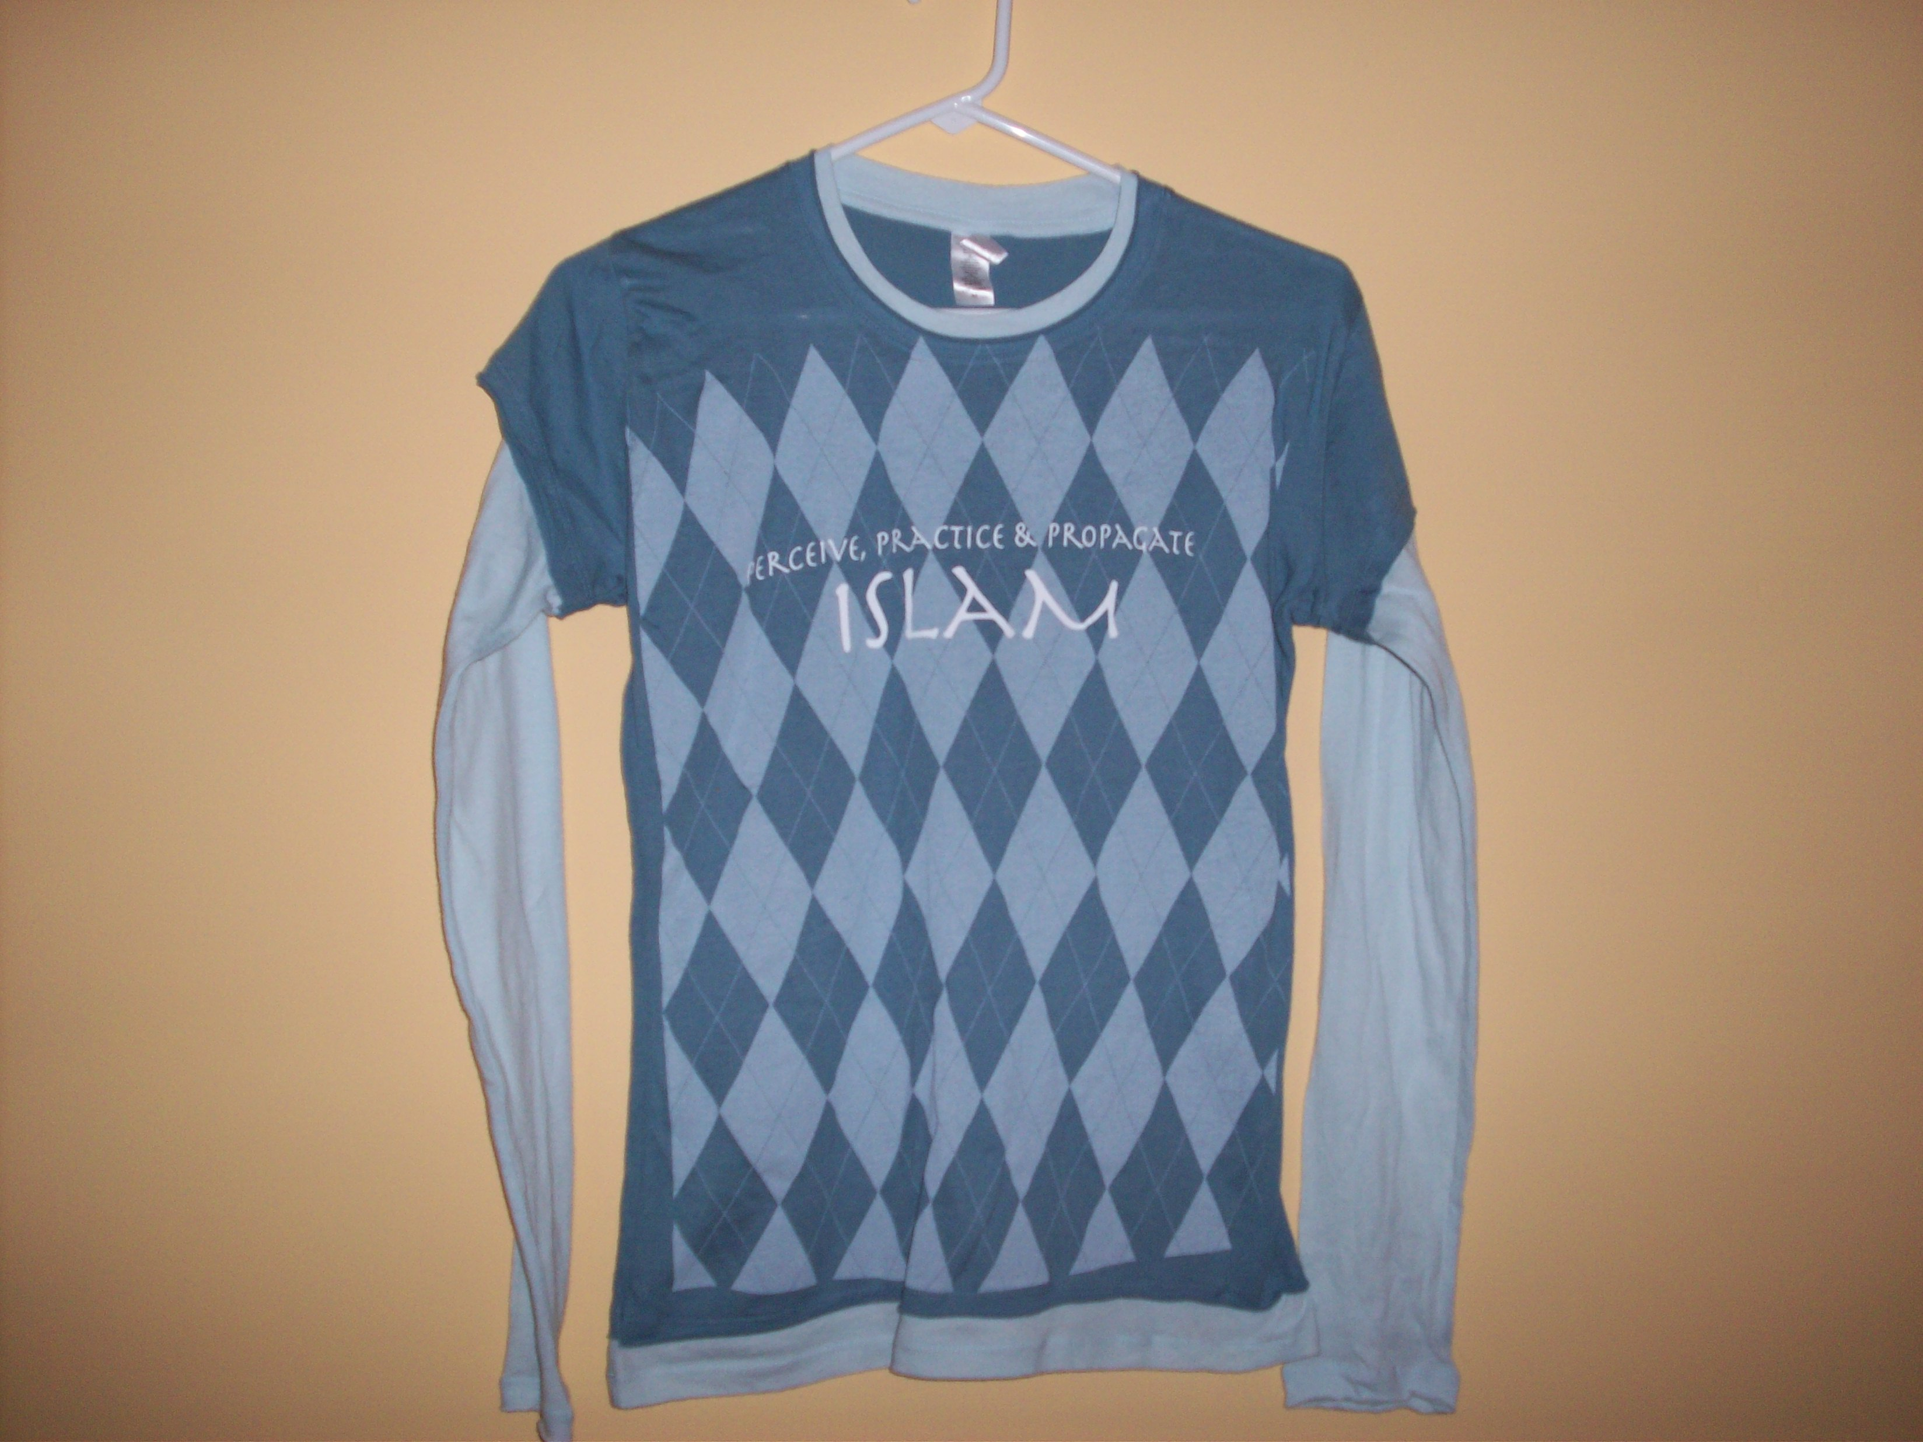
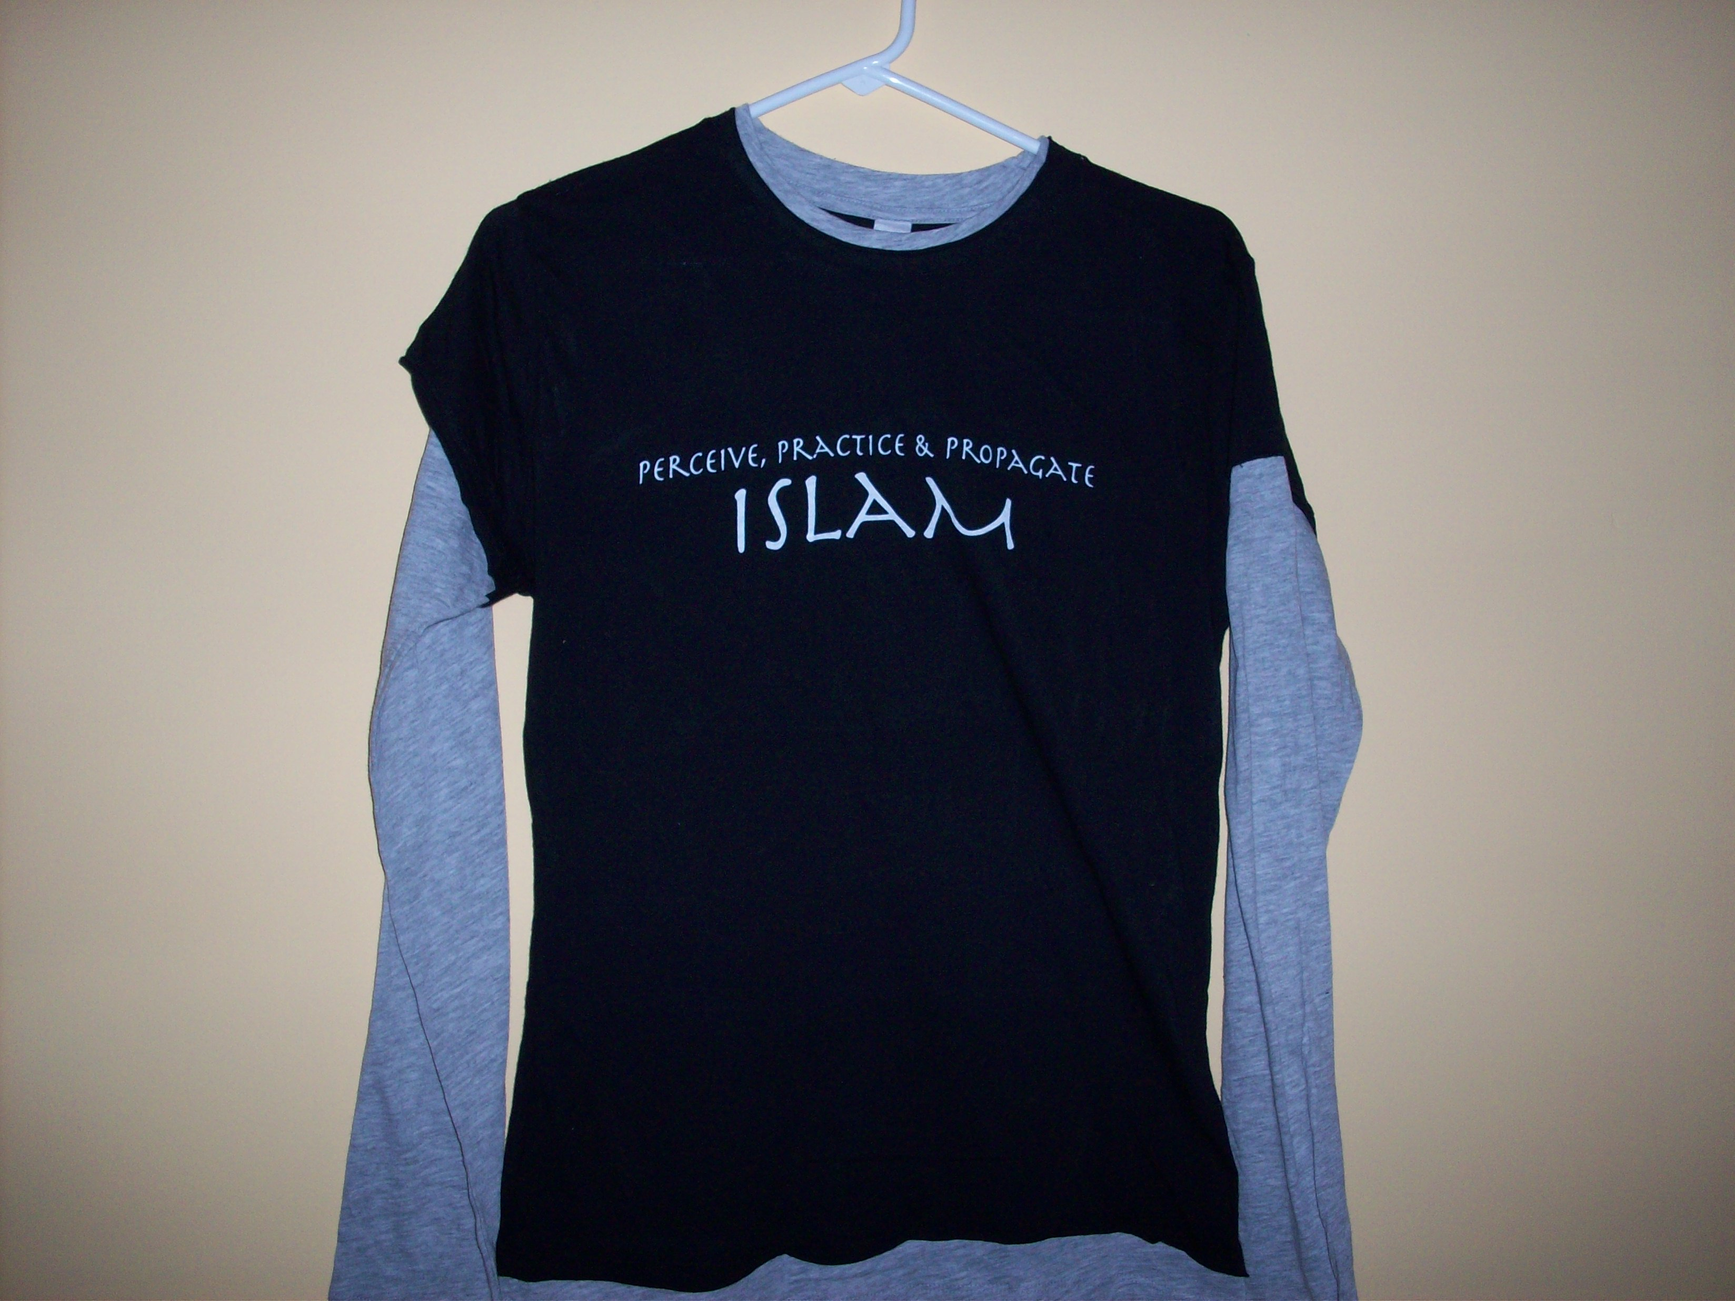
ICNF T-Shirts

$5.00 $5.00
Sizes (S, M, L, XL) Sizes (XL)

(Front) (Back)
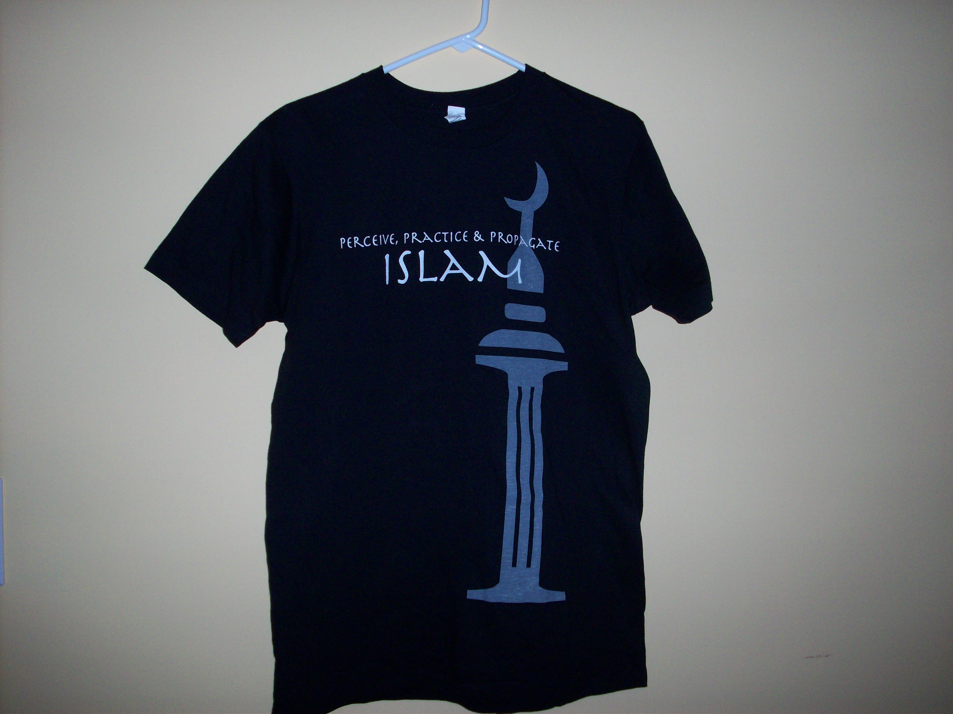
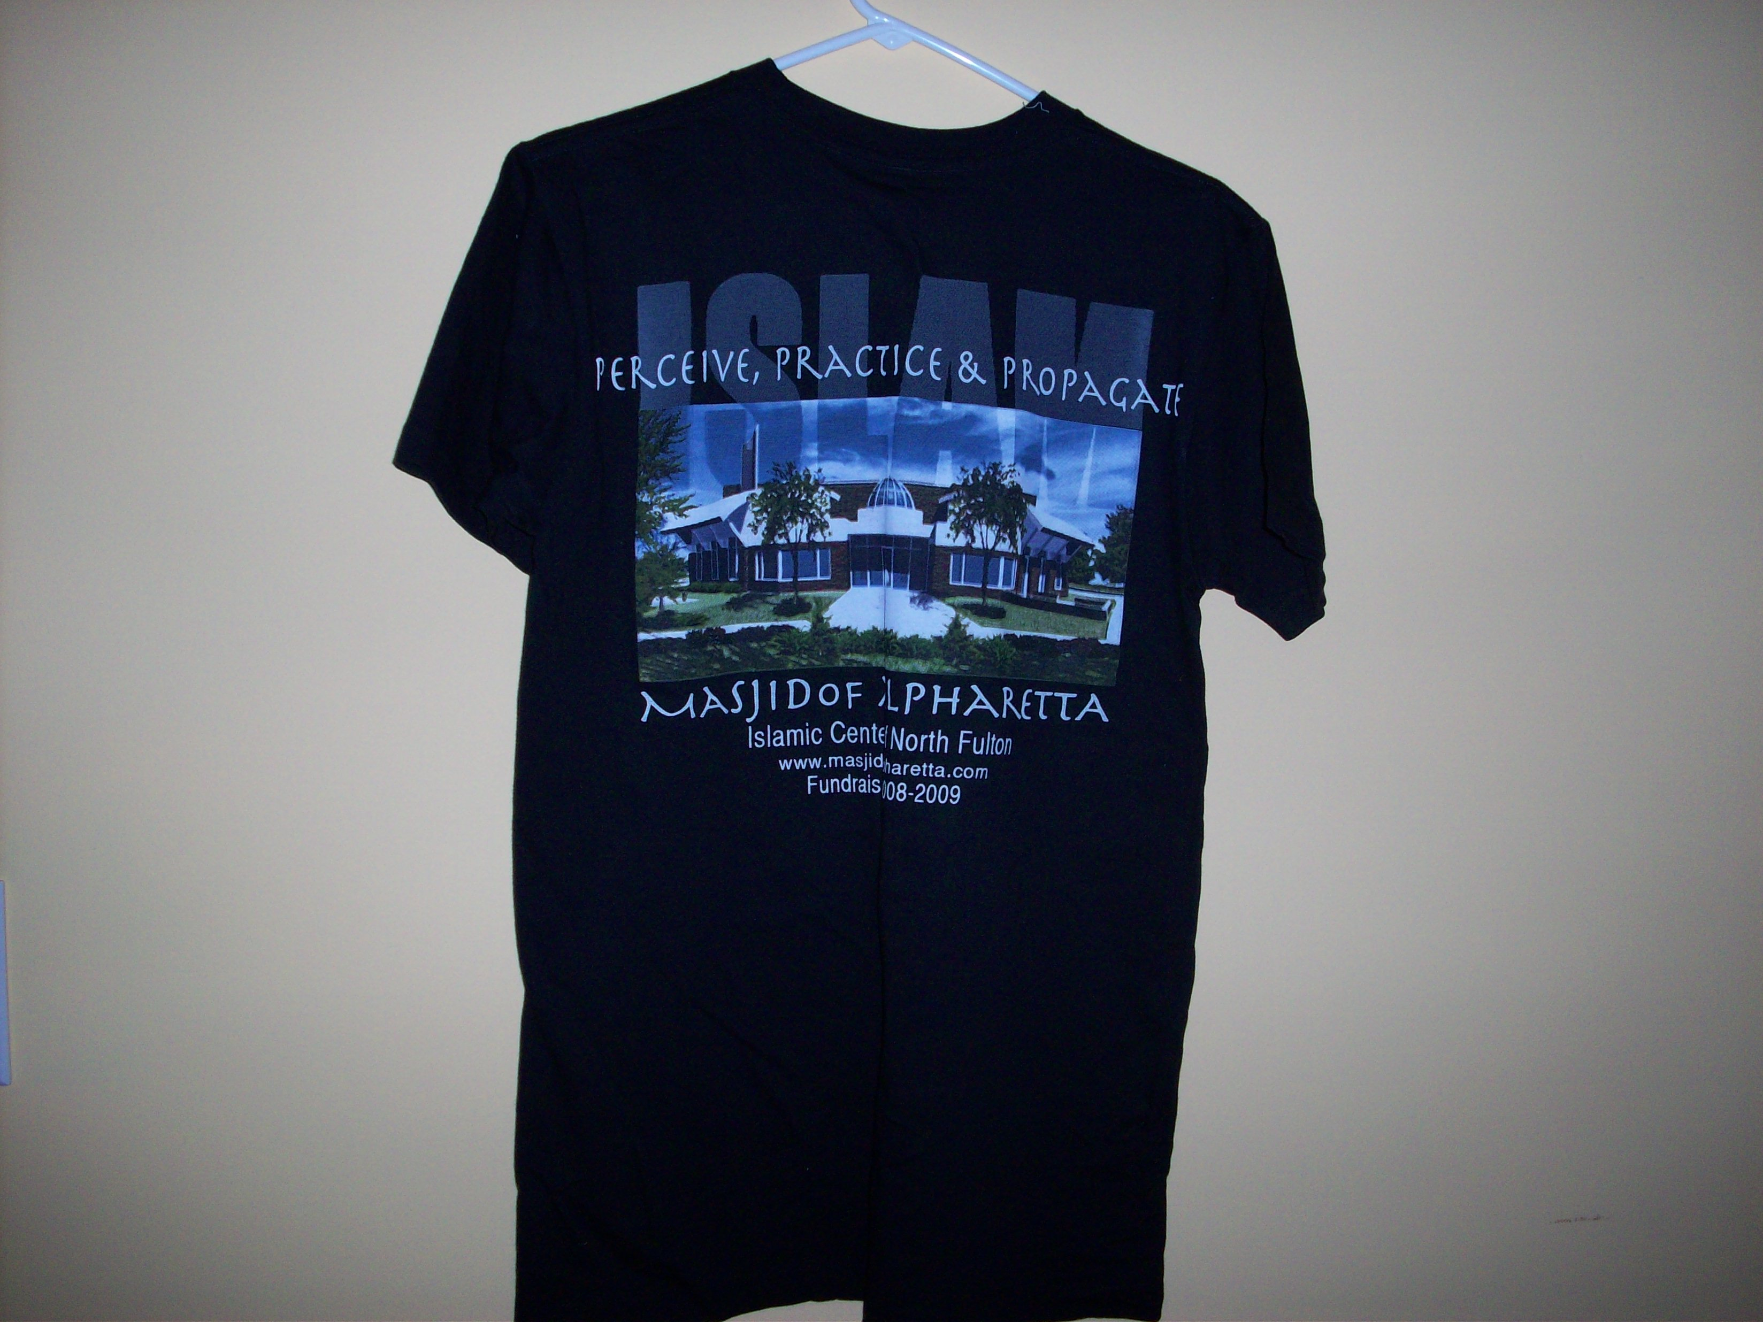

$3.00

Sizes (M, L, XL)
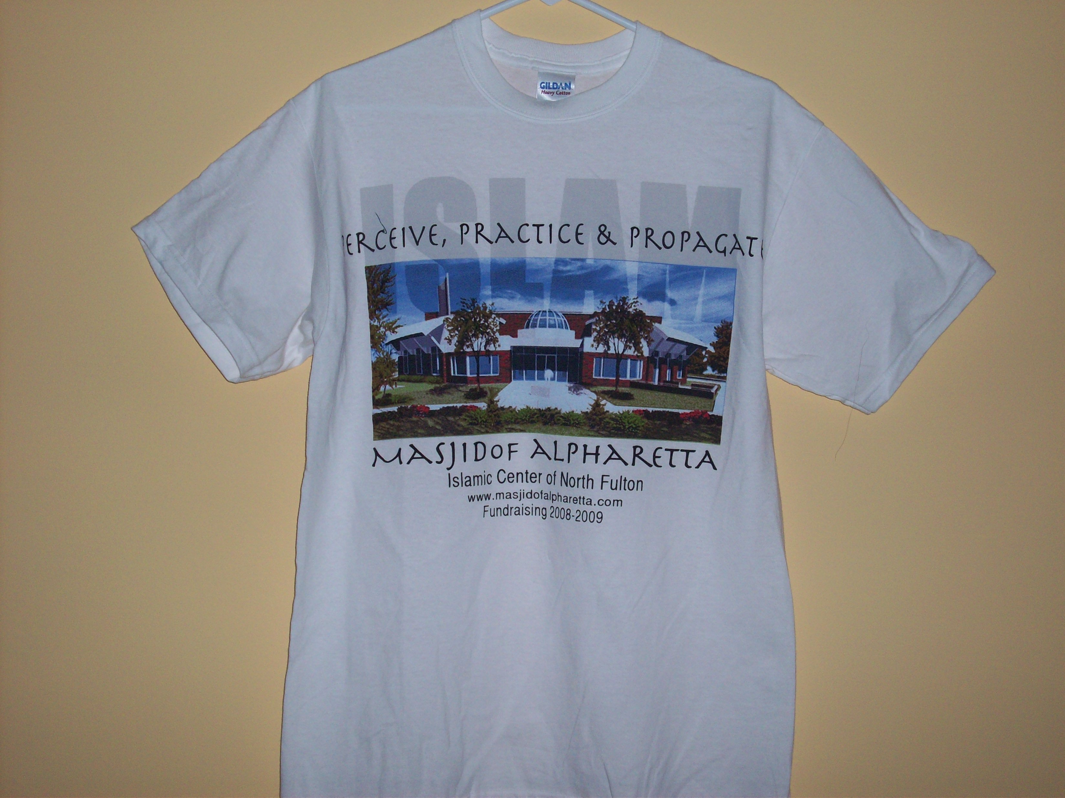
$3.00 Sizes (M, L, XL)

*** All proceeds go towards the construction of the new Alpharetta Masjid.

Shirts are available on Sundays at the Islamic Center of North Fulton
For more Info: e-mail Sister Rubeena at Rubrafi@yahoo.com or Sister Rashmi at RashmiKasam@yahoo.com

